To upload journal entries, a setting may need to be changed in Excel and/or Internet Options.
Excel Change
(varies based on version of Excel)
1. Open Excel
2. Click on “File” in top left corner
3. Click on “Options”
4. Click on “Trust Center” and then click on “Trust Center Settings”
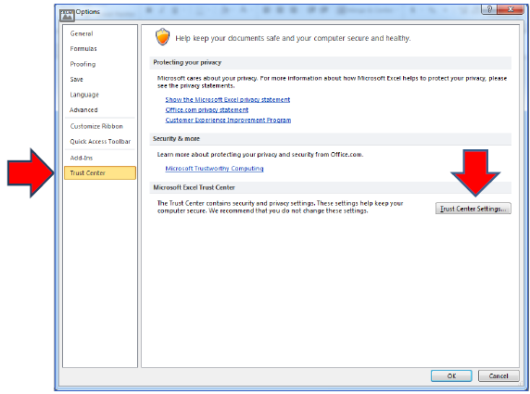

5. Click “Macro Settings”
6. Make sure “Enable all macros (not recommended; potentially dangerous code can run)” is selected and “Trust access to the VBA project object model” is also selected
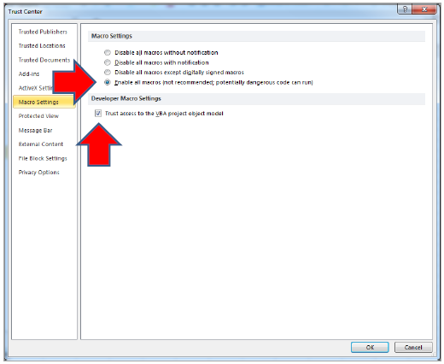
7. Click “OK” and close Excel

CONTINUE TO NEXT PAGE…

Internet Options Change
1. Open the internet options panel by typing "Internet Options" into the Windows search bar on the lower left of your screen
2. Click on the “Security” tab and then click on “Custom level…”
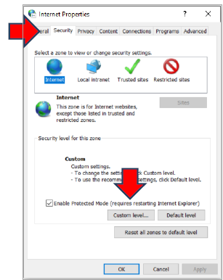

3. Scroll down to the “Scripting” category until you find “Allow status bar updates via script” and select “Enable”
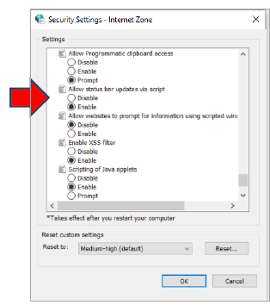
4. Click “OK”
5. A box will pop up asking if you are sure you want to make these changes, click “Yes”
6. Click “OK”
7. Close Internet Options

